**Cloud Computing Assignment: 5**

**TITLE:**

Assignment to install and configure your own cloud using OpenStack

**AIM:**

From this assignment we will understand the Configuration and installation of cloud using OpenStack.

**THEORY:**

**Introduction**

Cloud Computing allows the users to access a shared pool of computing resources like networks, servers, storage, applications, and services that can be rapidly provisioned. Essential Characteristics of Cloud Computing are on-demand, broad network access, resource pooling, measured service and rapid elasticity etc. Cloud computing has five deployment models as private cloud, public cloud, hybrid cloud, virtual private cloud and community cloud. Cloud computing has three service models, Infrastructure as a Service (IaaS), Platform as a Service (PaaS) and Software as a Service(SaaS).We propose the system architecture for building a private cloud which is capable of providing IaaS and PaaS as a service over the internet.

**OpenStack:**

OpenStack is open source software which the project developers and cloud computing technologist can use to setup and run the cloud. Its services can be accessed via APIs. The important components of OpenStack are Nova, Swift, Keystone and Glance, Keystone and Horizon.

**SYSTEM ARCHITECTURE**

The proposed system aims to build private cloud using open source software OpenStack. The system architecture of OpenStack is as depicted in Fig.1. The proposed system consists of various modules such as Horizon, Nova, Swift, Glance, and Keystone-













* **Nova**: Nova is the Computing Fabric controller for the OpenStack Cloud. The necessary activities for the life cycle of instances within the OpenStack cloud are handled by Nova. This characteristic makes Nova a Management Platform to manage various compute resources, networking, authorization, and scalability needs of the OpenStack cloud.
* **Glance**: Glance is a standalone service which provides a catalog service for storing and querying virtual disk images. Nova and Glance together provides an end-toend solution for cloud disk image management.
* **Swift**: Swift can store billions of virtual object distributed across the nodes. The swift offers built-in redundancy, failover management, archiving and media streaming. Swift plays an important role in scalability.

* **Keystone**: Keystone provides identity and access policy services for all components in the OpenStack family. All components of OpenStack including Swift, Glance, and Nova are authenticated and authorized by Keystone.
* **Horizon**: Horizon can be used to manage instances and images, create keypairs, attach volumes to instances, manipulate Swift containers etc.

**Advantages of OpenStack:**

✔ **Security**

Openstack allows for high level of security since the cloud deployment is done through a setup in the local machine. Additional layers of security like SSL encryption, Hypervisor security can also be done to secure the cloud system.

✔ **Scalability**

Openstack allows for usage of multiple machines across different locations or different servers for cloud setup. One can also scale up cloud systems by adding additional storage capacity into the system or additional processing systems.

✔ **Cost Savings**

You The OpenStack platform allows for cost savings since it doesn’t require any licenses to purchase or any kind of cost associated with cloud systems like Google Cloud or Amazon AWS. It requires setup of Openstack on a VM or a system of choice, which is free.

**CODE AND OUTPUT:**

Steps with output:

1. Download Install necessary packages to create compute nodes in Ubuntu using command- “**sudo apt-get install nova-api nova-cert nova-compute nova-compute-kvm nova-doc nova-network novaobjectstore nova-scheduler nova-volume rabbitmqserver novnc nova-consoleauth*”***
2. After successful installation of Compute node packages, we need to install control node packages using command- “**sudo apt-get install glance glance-api glance-client glance-common glance-registry python- glance**” . The command will ensure that glance API and Nova registry are working as expected.
3. Next, we need to install keystone packages using the command-“**sudo apt-get install keystone python-keystone pythonkeystoneclient**” **.**
4. Next, we want to install the Openstack dashboard using the following command**- “sudo apt-get install openstack-dashboard”.** On running the command, the command line prompt will show which would look like this-

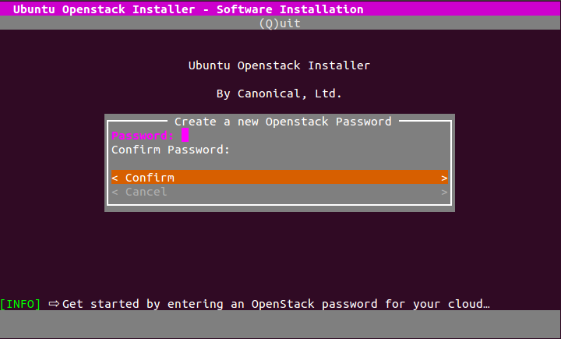

Here you have to create a password for OpenStack. In the next step, you have to specify the installation type-

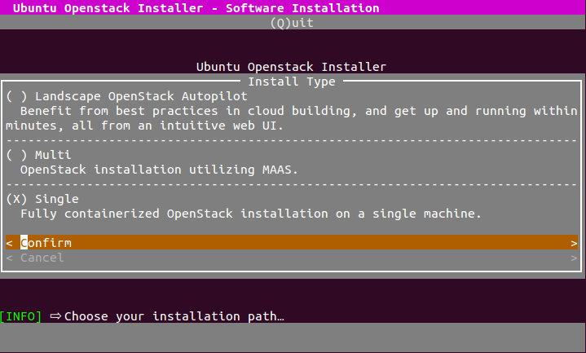Here, choose a single machine installation.

1. Once installation completes, you will be greeted with a dashboard that opens through a browser-:

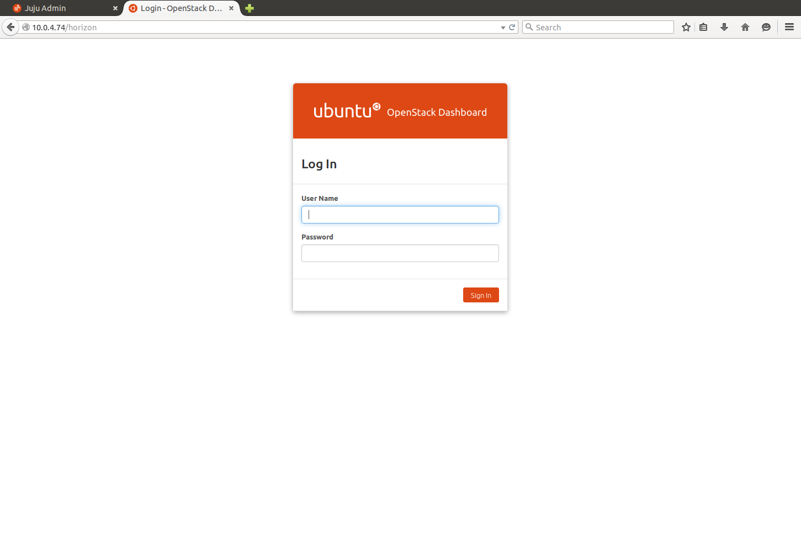

1. Install From here, one can access the Flavors page,which lists the currently available flavors which can be used to launch an instance:

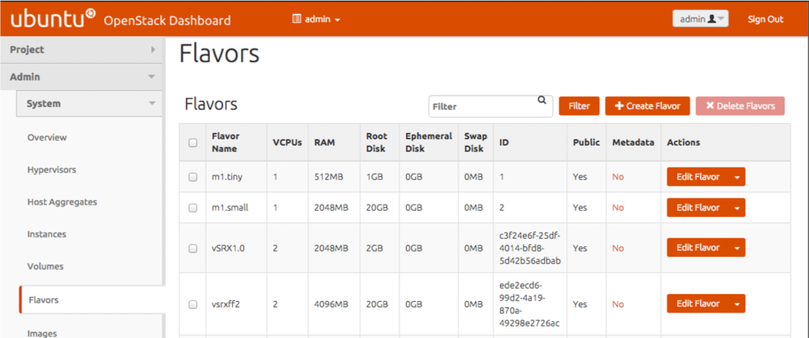

1. Openstack access and security page shows the access level for the private cloud and one can create new access levels from here-

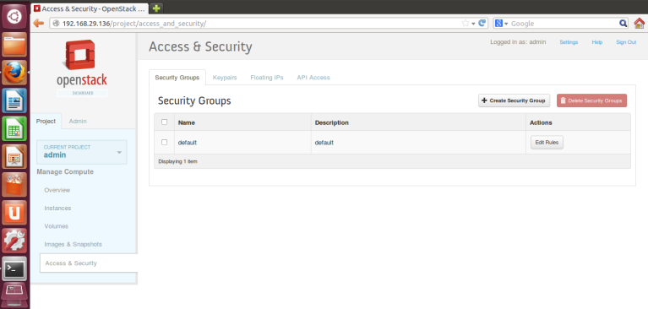

1. Change to the One can also access the list of hypervisors running currently in the OpenStack through the HyperVisors tab-

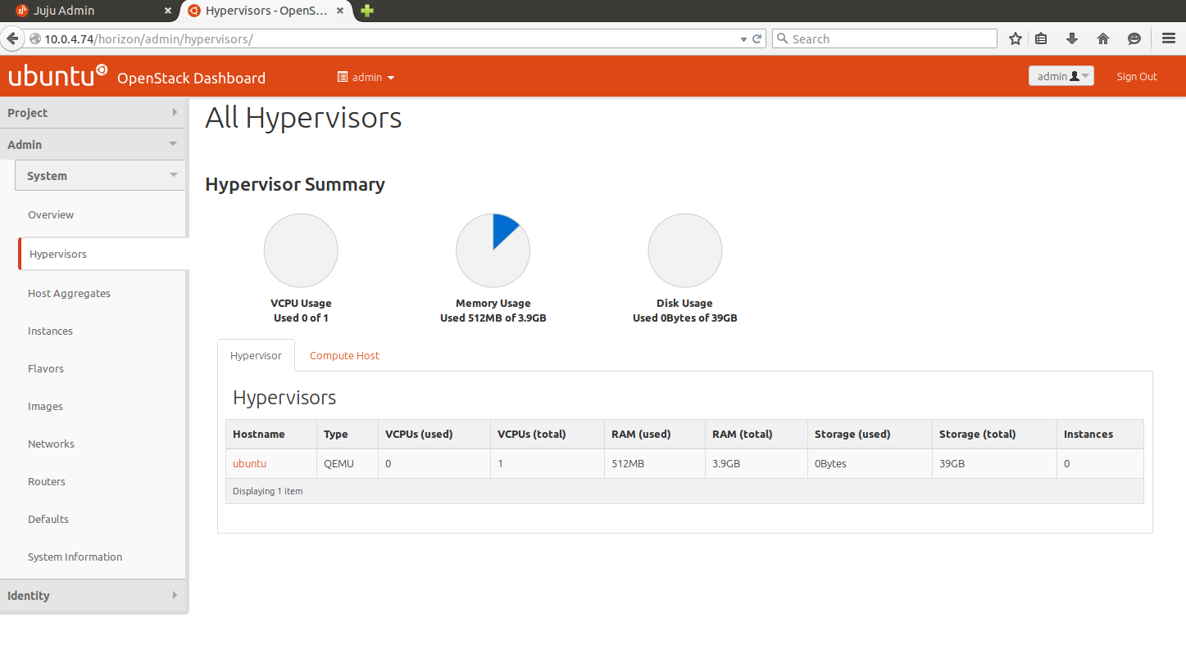

**CONCLUSION:**

Students were able to configure and create a private cloud using Openstack on a local machine.